**Detailed Business Specific Requirements:-**

**Theme**:Existing IT system for internal agencies of MoJS

**Applications**:WIMS expansion-WRIS

**Use Cases:-**Water Resources Projects -**WRIS-SSA-05**

**Other linked Use Case :-**Surface water Resources (RM-UC-01 to RM-UC-13) & (RBM-UC-01 to 15), Ground Water Resources (GWMUC-01 to 23), Water Utilization (IM-UC-01 to 11) & (CWM-UC-01 to 27), Water Quality (SWQ-UC-01 to 7) & (GWQ-UC-01 to 7), Water Harvesting (WT-UC-02 to 8), (WB-UC-01 to 10) & (WFP-UC-01 to 7), Event Analysis (GA-UC-01 to 9) & (DA-UC-01 to 9), Project Appraisal & Monitoring (PA-UC-01 to 8), Master Information System (WRIS-MIS-01 to 19).

**Description**:-

India’s geographical area is 329 Million hectare, total cultivable land is 181.95 million hectare. The gross sown area is 194.40 million hectare and net sown area is 139.93 million hectare. The ultimate irrigation potential of the country is 139.89 million hectare out of which from Major & Medium irrigation projects is 58.45 million hectare and rest Is from minor irrigation projects. Up to the end of Xl plan 113.93 million hectare potential is created and out of this the share from Major and Medium irrigation project is 47.97 million hectare. As per national Register of Large dam, the country has 5190 dams out of which 4877 are completed and 313 are under construction. The total storage capacity created so far is 253.388 Billion cubic meter (BCM) and 50.959 BCM is under creation. The hydro-electric potential of the country is 148701 MW out of which 145320 MW is from 25 MW capacity. The capacity developed so far is 38257 MW.

Water resources projects are broadly categorized into irrigation projects and hydroelectric projects. These projects are planned for various purposes like irrigation, hydro-power generation, water supply for drinking and industrial purpose, flood control navigation etc. Projects which serve more than one purpose are called as multipurpose projects. Generally majority of multipurpose projects are combination of irrigation and hydropower. There are many irrigation, hydro-power and multipurpose projects which were approved initially as independent projects. Subsequently due to interstate agreements and new projects coming up on downstream and upstream, water planning was done in such a way that operation of these projects are now done in an integrated manner. Such types of projects are now being called as irrigation, hydro power, multipurpose and complex.

**Reframe:-**

India covers a geographical area of 329 million hectares, with a total cultivable land of 181.95 million hectares. The gross sown area amounts to 194.40 million hectares, while the net sown area is 139.93 million hectares. The country's ultimate irrigation potential is estimated at 139.89 million hectares, of which 58.45 million hectares is derived from major and medium irrigation projects, with the remainder sourced from minor irrigation initiatives. By the end of the XI Plan, a total of 113.93 million hectares of this potential had been developed, including 47.97 million hectares from major and medium projects. According to the National Register of Large Dams, India has 5,190 dams, of which 4,877 are completed and 313 are still under construction. The total storage capacity achieved to date is 253.388 billion cubic meters (BCM), with an additional 50.959 BCM currently under development. The hydroelectric potential of the country stands at 148,701 MW, with 145,320 MW coming from plants with a capacity of 25 MW or more, and a total of 38,257 MW has been developed so far.

Water resource projects in India are primarily classified into irrigation and hydroelectric projects, designed for various purposes such as irrigation, hydro-power generation, drinking and industrial water supply, and flood control. Projects that serve multiple purposes are referred to as multipurpose projects, with most being a combination of irrigation and hydropower. Many irrigation, hydro-power, and multipurpose projects were initially approved as standalone initiatives. However, due to interstate agreements and the emergence of new projects upstream and downstream, water planning has evolved to facilitate the integrated operation of these projects. Consequently, these initiatives are now categorized as irrigation, hydro-power, multipurpose, and complex projects.

**Use Case: Water Resource Management in India**

**Use Case Name:** Water Resource Management

Use Case ID: UC-001

**Actors:**

* **Government Agencies**: Responsible for planning and implementing water resource projects.
* **Farmers**: Users of irrigation services for agricultural purposes.
* **Hydropower Companies**: Entities involved in generating electricity from water resources.
* **Water Supply Authorities**: Organizations managing water supply for drinking and industrial purposes.
* **Environmental Agencies**: Organizations monitoring the environmental impact of water resource projects.

**Preconditions:**

* Comprehensive data on geographical area, cultivable land, irrigation potential, and existing water resource projects is available.
* Relevant stakeholders are identified and engaged in the planning process.

**Postconditions:**

* Effective management and utilization of water resources for irrigation, hydropower generation, and other purposes.
* Improved agricultural productivity and energy generation.
* Sustainable water resource management practices are implemented.

**Main Flow:**

1. **Data Collection and Analysis:**
   * Government agencies collect data on geographical area, cultivable land, gross and net sown areas, and irrigation potential.
   * Analyze the data to identify regions with irrigation needs and hydropower potential.
2. **Project Planning:**
   * Identify and categorize water resource projects (irrigation, hydroelectric, multipurpose).
   * Develop plans for new projects based on the analysis, considering existing projects and interstate agreements.
3. **Stakeholder Engagement:**
   * Engage with farmers, hydropower companies, and water supply authorities to gather input and address concerns.
   * Conduct public consultations to inform stakeholders about planned projects and gather feedback.
4. **Project Implementation:**
   * Implement irrigation projects to enhance agricultural productivity.
   * Construct hydropower projects to generate electricity.
   * Develop multipurpose projects that serve multiple needs (irrigation, power generation, flood control).
5. **Monitoring and Evaluation:**
   * Monitor the performance of water resource projects to ensure they meet their objectives.
   * Evaluate the impact of projects on agricultural productivity, energy generation, and environmental sustainability.
6. **Integrated Water Resource Management:**
   * Coordinate the operation of irrigation and hydropower projects to optimize water usage.
   * Adjust project operations based on real-time data and changing conditions (e.g., droughts, floods).
7. **Reporting and Feedback:**
   * Generate reports on the status and performance of water resource projects.
   * Provide feedback to stakeholders and make necessary adjustments to project plans and operations.

**Alternate Flow:**

* If data is insufficient or outdated, initiate a data collection campaign to gather the necessary information before proceeding with project planning.

**Benefits:**

* Enhanced agricultural productivity through improved irrigation.
* Increased energy generation from hydropower projects.
* Sustainable management of water resources, balancing the needs of agriculture, energy, and environmental protection.
* Improved collaboration among stakeholders, leading to more effective water resource management.

**Summary:-**

The use case for water resource management in India outlines a comprehensive approach to effectively utilize the country's water resources for irrigation, hydropower generation, and other purposes. It involves the collection and analysis of data on geographical areas, cultivable land, and irrigation potential to identify regions in need of development. Government agencies engage with stakeholders, including farmers, hydropower companies, and water supply authorities, to gather input and address concerns during the planning phase. The implementation of irrigation and hydropower projects, along with multipurpose initiatives, aims to enhance agricultural productivity and energy generation. Continuous monitoring and evaluation ensure that projects meet their objectives while promoting sustainable practices. By coordinating the operation of various projects and adjusting plans based on real-time data, the use case emphasizes the importance of integrated water resource management, ultimately leading to improved collaboration among stakeholders and more effective management of India's water resources.

**Figure 001_Intro_Usecase_PlantUML**

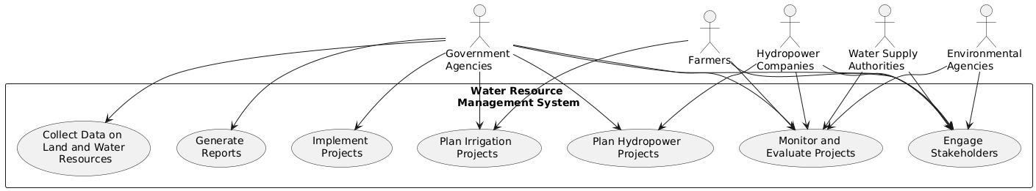

**Code for Figure 001_Intro_Usecase_PlantUML**

@startuml

RECTANGLE "Water Resource \nManagement System" {

usecase "Collect Data on \nLand and Water\n Resources" as UC1

usecase "Plan Irrigation \nProjects" as UC2

usecase "Plan Hydropower \nProjects" as UC3

usecase "Engage \nStakeholders" as UC4

usecase "Implement \nProjects" as UC5

usecase "Monitor and \nEvaluate Projects" as UC6

usecase "Generate \nReports" as UC7

}

actor "Government \nAgencies" as GA

actor "Farmers" as F

actor "Hydropower \nCompanies" as HC

actor "Water Supply \nAuthorities" as WSA

actor "Environmental \nAgencies" as EA

GA --> UC1

GA --> UC2

GA --> UC3

GA --> UC4

GA --> UC5

GA --> UC6

GA --> UC7

F --> UC2

F --> UC4

F --> UC6

HC --> UC3

HC --> UC4

HC --> UC6

WSA --> UC4

WSA --> UC6

EA --> UC4

EA --> UC6

@enduml

**Figure 001_Intro_flowchart_NapkinAI**

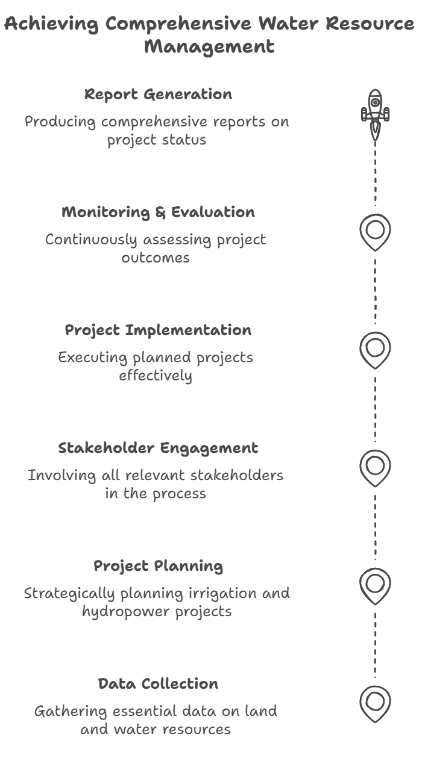

**Used By (End Users):-**Researcher, Decision makers, administrators, academicians and public.

**Figure 002_End users_Usecase_PlantUML**

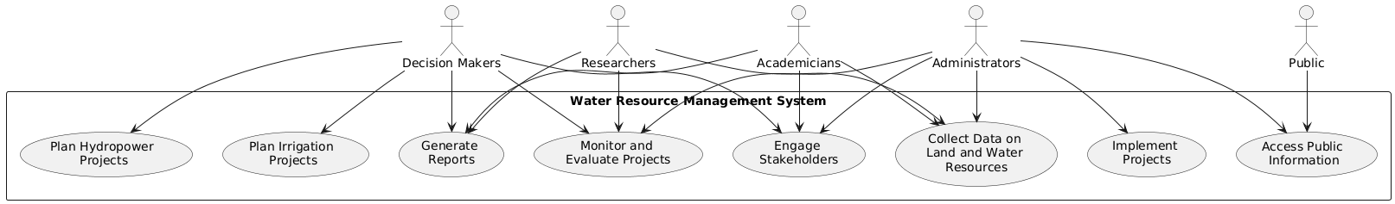

**Code for Figure 002_End users_Usecase_PlantUML**

@startuml

RECTANGLE "Water Resource Management System" {

usecase "Collect Data on \nLand and Water \nResources" as UC1

usecase "Plan Irrigation \nProjects" as UC2

usecase "Plan Hydropower \nProjects" as UC3

usecase "Engage \nStakeholders" as UC4

usecase "Implement \nProjects" as UC5

usecase "Monitor and \nEvaluate Projects" as UC6

usecase "Generate \nReports" as UC7

usecase "Access Public \nInformation" as UC8

}

actor "Researchers" as R

actor "Decision Makers" as DM

actor "Administrators" as A

actor "Academicians" as AC

actor "Public" as P

R --> UC1

R --> UC6

R --> UC7

DM --> UC2

DM --> UC3

DM --> UC4

DM --> UC6

DM --> UC7

A --> UC1

A --> UC4

A --> UC5

A --> UC6

A --> UC8

AC --> UC1

AC --> UC4

AC --> UC7

P --> UC8

@enduml

**Figure 002_End users_flowchart_NoteGPT_with_mermaid_code**

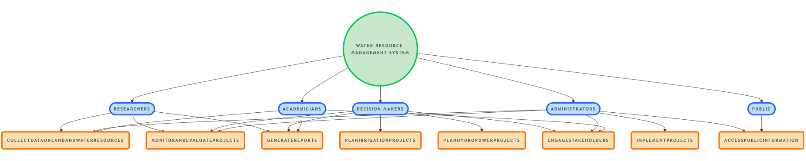

**Code for Figure 002_End users_flowchart_NoteGPT_with_mermaid_code**

flowchart TD

A(("Water Resource Management System")) --> R1(["Researchers"])

A --> DM1(["Decision Makers"])

A --> A1(["Administrators"])

A --> AC1(["Academicians"])

A --> P1(["Public"])

R1 --> UC1("CollectDataOnLandAndWaterResources")

R1 --> UC6("MonitorAndEvaluateProjects")

R1 --> UC7("GenerateReports")

DM1 --> UC2("PlanIrrigationProjects")

DM1 --> UC3("PlanHydropowerProjects")

DM1 --> UC4("EngageStakeholders")

DM1 --> UC6

DM1 --> UC7

A1 --> UC1

A1 --> UC4

A1 --> UC5("ImplementProjects")

A1 --> UC6

A1 --> UC8("AccessPublicInformation")

AC1 --> UC1

AC1 --> UC4

AC1 --> UC7

P1 --> UC8

style A fill:#C8E6C9,stroke-width:4px,stroke-dasharray: 0,stroke:#00C853

style R1 stroke-width:4px,stroke-dasharray: 0,fill:#BBDEFB,stroke:#2962FF

style DM1 stroke-width:4px,stroke-dasharray: 0,fill:#BBDEFB,stroke:#2962FF

style A1 stroke-width:4px,stroke-dasharray: 0,fill:#BBDEFB,stroke:#2962FF

style AC1 stroke-width:4px,stroke-dasharray: 0,fill:#BBDEFB,stroke:#2962FF

style P1 stroke-width:4px,stroke-dasharray: 0,fill:#BBDEFB,stroke:#2962FF

style UC1 stroke-width:4px,stroke-dasharray: 0,fill:#FFE0B2,stroke:#FF6D00

style UC2 stroke-width:4px,stroke-dasharray: 0,fill:#FFE0B2,stroke:#FF6D00

style UC3 stroke-width:4px,stroke-dasharray: 0,fill:#FFE0B2,stroke:#FF6D00

style UC4 stroke-width:4px,stroke-dasharray: 0,fill:#FFE0B2,stroke:#FF6D00

style UC5 stroke-width:4px,stroke-dasharray: 0,fill:#FFE0B2,stroke:#FF6D00

style UC6 stroke-width:4px,stroke-dasharray: 0,fill:#FFE0B2,stroke:#FF6D00

style UC7 stroke-width:4px,stroke-dasharray: 0,fill:#FFE0B2,stroke:#FF6D00

style UC8 stroke-width:4px,stroke-dasharray: 0,fill:#FFE0B2,stroke:#FF6D00

**Figure 002_End users_Usecase_NapkinAI**

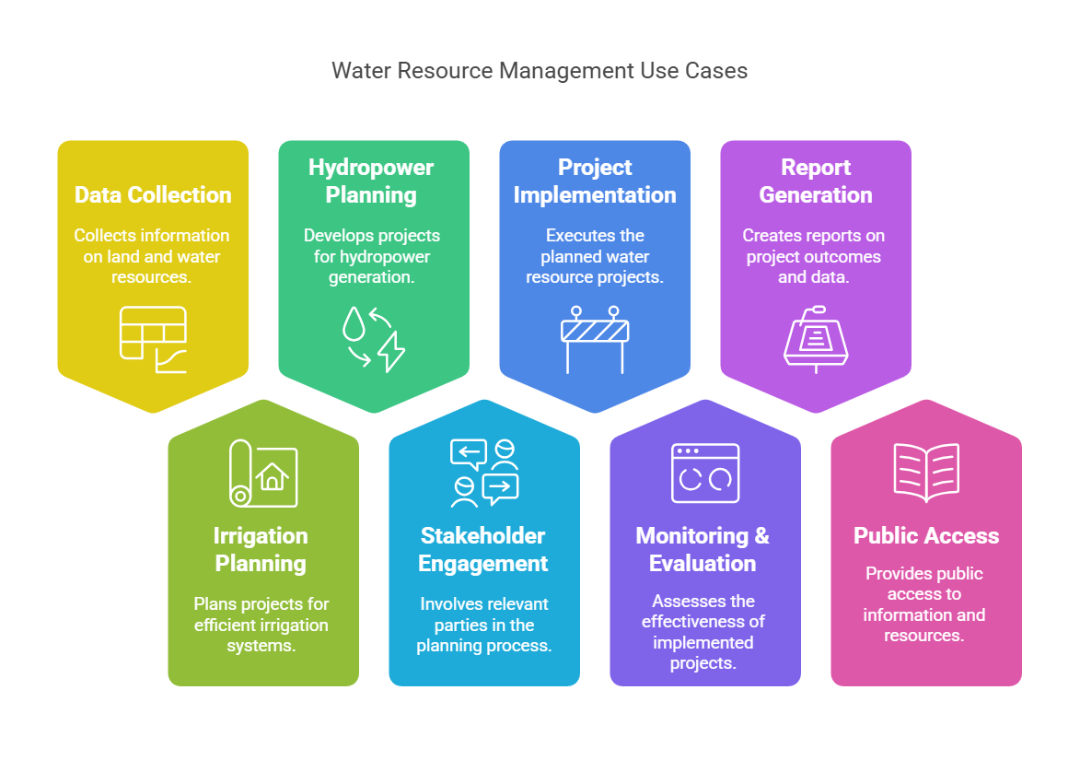**Priority**:- **High Priority**

**Phase:-Phase 1**of WARIMS under WIMS expansion-WRIS

**Governance Need (Business Problem):-**

**Issue**:-Survey sheets done by various authorized state and central water resources division are provided in the hard copy formats & that requires digitization and further GIS operations for data extraction & final hosting in the module. Manual error while generation of the GIS data in different stages of data creation may increase in different steps. Database containg all the water resources projects/structures are generated, compiled and disseminated under the Water Resources Projects module. The existing system of generation and dissemination of data in respect of major and medium irrigation projects does not provide real time monitoring of inflows of water and its utilization through canals and the distributory system. Due to improper management of soil and water resources in the command area, the problems of salinity and water logging are reported to be increased.

**Reframe:-**Survey sheets completed by various authorized state and central water resources divisions are currently available in hard copy formats, necessitating digitization and subsequent GIS operations for data extraction and final integration into the module. The manual processes involved in generating GIS data at different stages of creation can lead to increased errors. A comprehensive database containing all water resource projects and structures is compiled and disseminated under the Water Resources Projects module. However, the existing system for generating and disseminating data related to major and medium irrigation projects lacks real-time monitoring capabilities for water inflows and their utilization through canals and the distributory system. Additionally, improper management of soil and water resources in the command area has resulted in escalating issues of salinity and waterlogging.

**Use Case: Water Resources Data Management and Monitoring**

**Use Case Name:** Water Resources Data Management and Monitoring

**Actors:**

* **Water Resource Division Staff**: Responsible for conducting surveys and managing data.
* **GIS Specialists**: Handle the digitization and GIS operations for data extraction.
* **Database Administrators**: Manage the database of water resource projects and structures.
* **Decision Makers**: Use the data for planning and decision-making.
* **Farmers**: Affected by the management of water resources and soil conditions.

**Preconditions:**

* Survey sheets are available in hard copy format.
* Authorized personnel are trained in data digitization and GIS operations.
* A database system is in place to store and manage water resource project data.

**Postconditions:**

* Digitized data is accurately integrated into the GIS module.
* A comprehensive database of water resource projects is maintained.
* Real-time monitoring of water inflows and utilization is established.
* Issues related to salinity and waterlogging are identified and addressed.

**Main Flow:**

1. **Survey Data Collection:**
   * Water Resource Division Staff conduct surveys and complete survey sheets in hard copy format.
2. **Digitization of Survey Data:**
   * GIS Specialists receive the hard copy survey sheets.
   * They digitize the data and perform GIS operations for data extraction.
3. **Data Integration:**
   * The digitized data is integrated into the Water Resources Projects module.
   * GIS Specialists ensure that the data is accurately represented in the system.
4. **Database Management:**
   * Database Administrators compile and maintain a comprehensive database of all water resource projects and structures.
   * They ensure that the database is updated with the latest information.
5. **Real-Time Monitoring:**
   * Implement a system for real-time monitoring of water inflows and utilization through canals and the distributory system.
   * Decision Makers access this data for informed planning and management.
6. **Issue Identification:**
   * Monitor the command area for issues related to salinity and waterlogging.
   * Farmers report any problems they encounter due to improper management of soil and water resources.
7. **Reporting and Feedback:**
   * Generate reports on the status of water resource projects and any identified issues.
   * Provide feedback to relevant stakeholders for necessary actions.

**Alternate Flow:**

* If errors are detected during the digitization process, GIS Specialists will review and correct the data before integration into the module.

**Benefits:**

* Improved accuracy and accessibility of water resource data through digitization and GIS integration.
* Enhanced decision-making capabilities with real-time monitoring of water inflows and utilization.
* Proactive identification and management of salinity and waterlogging issues, leading to better soil and water resource management.

**Summary:-**The use case for Water Resources Data Management and Monitoring outlines a systematic approach to digitizing survey data collected by authorized state and central water resources divisions, which are initially available in hard copy formats. GIS specialists are responsible for converting this data into digital formats and integrating it into a comprehensive database of water resource projects and structures. The system aims to establish real-time monitoring of water inflows and their utilization through canals and distributory systems, enabling informed decision-making by stakeholders. Additionally, the use case addresses the proactive identification of issues related to salinity and waterlogging in command areas, ultimately enhancing the management of soil and water resources and improving agricultural outcomes.

**Figure 003_issue_Usecase_PlantUML**

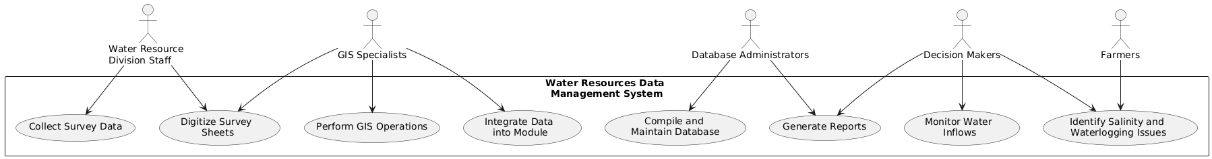

**Code for Figure 003_issue_Usecase_PlantUML**

@startuml

RECTANGLE "Water Resources Data \nManagement System" {

usecase "Collect Survey Data" as UC1

usecase "Digitize Survey \nSheets" as UC2

usecase "Perform GIS Operations" as UC3

usecase "Integrate Data \ninto Module" as UC4

usecase "Compile and \nMaintain Database" as UC5

usecase "Monitor Water \nInflows" as UC6

usecase "Identify Salinity and \nWaterlogging Issues" as UC7

usecase "Generate Reports" as UC8

}

actor "Water Resource \nDivision Staff" as WRDS

actor "GIS Specialists" as GIS

actor "Database Administrators" as DBA

actor "Decision Makers" as DM

actor "Farmers" as F

WRDS --> UC1

WRDS --> UC2

GIS --> UC2

GIS --> UC3

GIS --> UC4

DBA --> UC5

DBA --> UC8

DM --> UC6

DM --> UC7

DM --> UC8

F --> UC7

@enduml

**Figure 003_issue_flowchart_NoteGPT_with_mermaid_code**

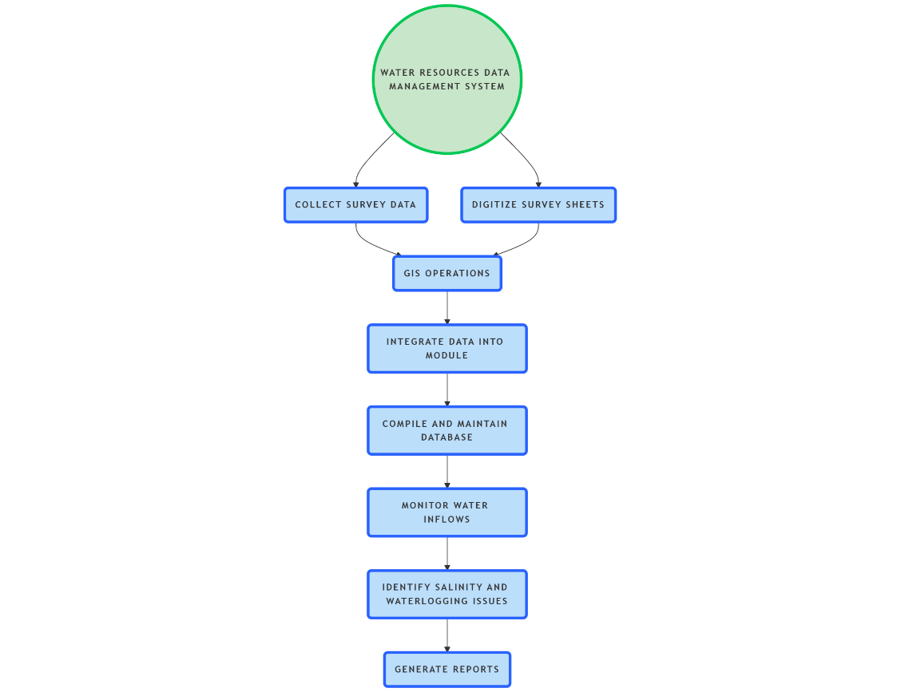

**Code for Figure 003_issue_flowchart_NoteGPT_with_mermaid_code**

flowchart TD

A(("Water Resources Data Management System")) --> n1("Collect Survey Data")

A --> n2("Digitize Survey Sheets")

n1 --> n3("GIS Operations")

n2 --> n3

n3 --> n4("Integrate Data into Module")

n4 --> n5("Compile and Maintain Database")

n5 --> n6("Monitor Water Inflows")

n6 --> n7("Identify Salinity and Waterlogging Issues")

n7 --> n8("Generate Reports")

style A fill:#C8E6C9,stroke-width:4px,stroke-dasharray: 0,stroke:#00C853

style n1 stroke-width:4px,stroke-dasharray: 0,fill:#BBDEFB,stroke:#2962FF

style n2 stroke-width:4px,stroke-dasharray: 0,fill:#BBDEFB,stroke:#2962FF

style n3 stroke-width:4px,stroke-dasharray: 0,fill:#BBDEFB,stroke:#2962FF

style n4 stroke-width:4px,stroke-dasharray: 0,fill:#BBDEFB,stroke:#2962FF

style n5 stroke-width:4px,stroke-dasharray: 0,fill:#BBDEFB,stroke:#2962FF

style n6 stroke-width:4px,stroke-dasharray: 0,fill:#BBDEFB,stroke:#2962FF

style n7 stroke-width:4px,stroke-dasharray: 0,fill:#BBDEFB,stroke:#2962FF

style n8 stroke-width:4px,stroke-dasharray: 0,fill:#BBDEFB,stroke:#2962FF

**Figure 003_issue_Usecase_NapkinAI**

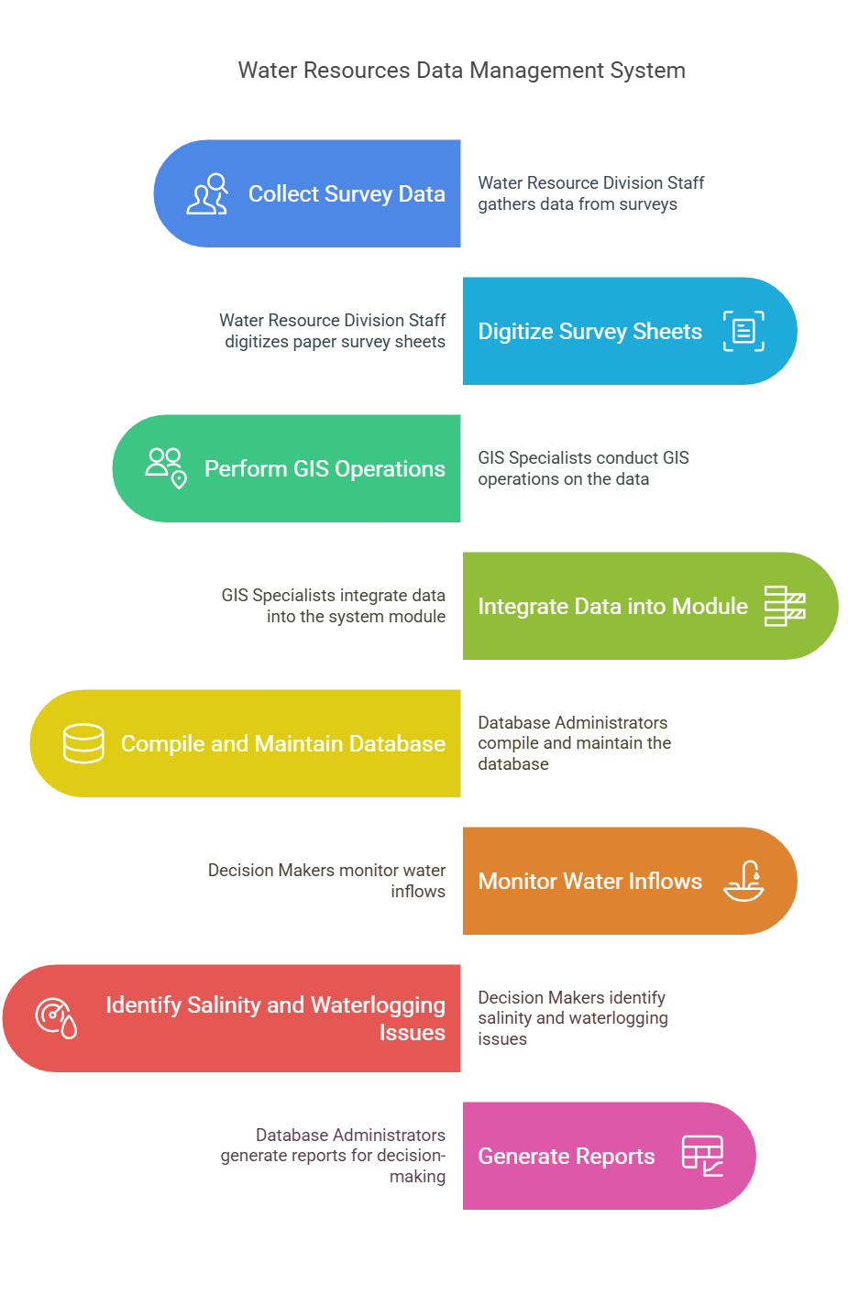

**Approach**:-Currently hardcopy information related to WRP is available for digitalization of data, but digital GIS based data Is available with mapping and project development agencies. This digital data is highly required to enrich WRP database and its applications. Monitoring the crop acreage and irrigation water requirements vise-a-via irrigation water supplies is important to obtain a realistic view of the “irrigation potential” and “potential utilized”. Satellite data provides information on crop area and thereby net irrigation water requirements of crops. After generation of soil salinity & water logging data which will be incorporated into the WRP module will be helpful for planner and policy makers to address the issue.

**Output:-**This module provides spatial inventory of the water resources projects like irrigation projects & hydroelectric projects as well as structures like (Dam, Barrage, weir, anicut, lift, canal, powerhouse) with their associated non spatial attributes/information in detail throughout the country.

**Expected Outcome:-**Water resources projects module contains a comprehensive database of India’s water resources and related structures. Country level digital database of various water resources themes in the form of maps and reports.

**Visualization:-**

**A) Map at India Level** - Map showing the hydrological boundaries and the major medium irrigation commands along with their associated features across the country.

**Fig 1: Water resources projects at PAN India Level**

**Figure 004_map_at_india_level_SeqDiag_PlantUML**

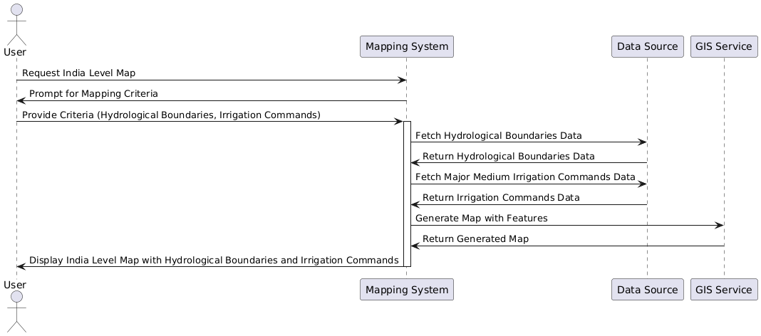

**Code for Figure 004_map_at_india_level_SeqDiag_PlantUML**

@startuml

actor User

participant "Mapping System" as MappingSystem

participant "Data Source" as DataSource

participant "GIS Service" as GISService

User -> MappingSystem: Request India Level Map

MappingSystem -> User: Prompt for Mapping Criteria

User -> MappingSystem: Provide Criteria (Hydrological Boundaries, Irrigation Commands)

activate MappingSystem

MappingSystem -> DataSource: Fetch Hydrological Boundaries Data

DataSource -> MappingSystem: Return Hydrological Boundaries Data

MappingSystem -> DataSource: Fetch Major Medium Irrigation Commands Data

DataSource -> MappingSystem: Return Irrigation Commands Data

MappingSystem -> GISService: Generate Map with Features

GISService -> MappingSystem: Return Generated Map

MappingSystem -> User: Display India Level Map with Hydrological Boundaries and Irrigation Commands

deactivate MappingSystem

@enduml

**B) Visualization :**

**1) Spatial Data Query:** Using the “Spatial data query” tool, the user can set his own set of query and get information about the particular project/structure in the map spatially.

I) **Get feature info tool:** User can get information about any particular data/structure by simply clicking individual features as shown in Fig.

II**) Info Summary tool:** User can view and get overall information of a large database related to Dam, Barrage / Weir / Anicut, Lift stations, Reservoir, Major & Medium Irrigation Projects, Extension Renovation and Modernization (ERM) projects, HydroElectric projects in the “Info Summary” tool in the data panel. This summary will be available for country level, administrative (state/district} & Hydrological (basin/sub basin) level as per the user query.

III) Option for “Pin Mark” & “drawing tool” will be available to define the user specific area (point ,line & Polygon).

IV) There will be a strong feature search option for all the layers of this module.

* search by name
* Search by Location
* Search by Purpose
* Search by Irrigation Project

Fig: Search bar as shown at the Top of the module

V) As a user search any structure (i.e. Dam, BWA, Lift, power house) the associated structure/ project list will be appear which will be interlinked with the map features & will provide in-depth detail of associated entities as shown below Fig..

Fig: Spatial query provide in-depth detail of associated entities

VI) Options for uploading (kml or shp file) or enter the latitude and longitude of an user define location/area will be there.

VII) Search by proximity option or search based on the distance/buffer (i.e. 1km, km, 10 km buffer) of a particular point, all the water resources structures as well major medium irrigation project/hydro electric projects list will appear (as shown below).

Fig-4: Nearby/proximity tool showing nearby features of Rajghat dam

VIII) Based on the administrative/ hydrological basin boundaries tables/reports will be generated based on the user defined query.

**IX) Map Generation:** A map of irrigation project depicting location of its associated dam, reservoir, irrigation command etc will be generated with proper format (north arrow, grid, legend, scale) (Fig-6).

**Figure 005_Visualization_spatial_data_SeqDiag_PlantUML**

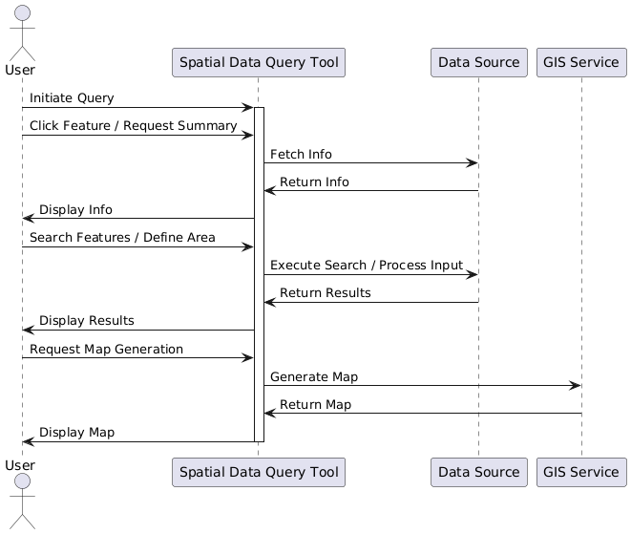

**Code for Figure 005_Visualization_spatial_data_SeqDiag_PlantUML**

@startuml

actor User

participant "Spatial Data Query Tool" as QueryTool

participant "Data Source" as DataSource

participant "GIS Service" as GISService

User -> QueryTool: Initiate Query

activate QueryTool

User -> QueryTool: Click Feature / Request Summary

QueryTool -> DataSource: Fetch Info

DataSource -> QueryTool: Return Info

QueryTool -> User: Display Info

User -> QueryTool: Search Features / Define Area

QueryTool -> DataSource: Execute Search / Process Input

DataSource -> QueryTool: Return Results

QueryTool -> User: Display Results

User -> QueryTool: Request Map Generation

QueryTool -> GISService: Generate Map

GISService -> QueryTool: Return Map

QueryTool -> User: Display Map

deactivate QueryTool

@enduml

**2) Non spatial query builder and report generation:**As the water resources database contains huge non spatial data associated with each feature/structure, non spatial query based on features/attributes/administrative/ hydrological basin can be incorporated with the module. Few Examples — I) Number of dams of any particular district/ state/basin/sub basin; II) Number of dams having height more than 300m; III) No of multipurpose projects of the country; IV) Name of the BWA having length more than 1000 m.etc.

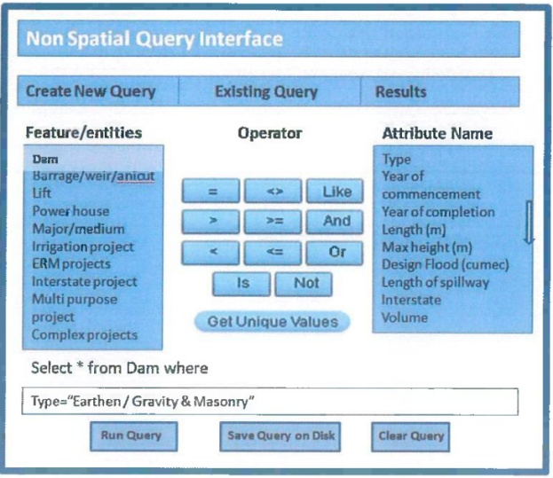

**Figure 006_Visualization_non_spatial_data_SeqDiag_PlantUML**

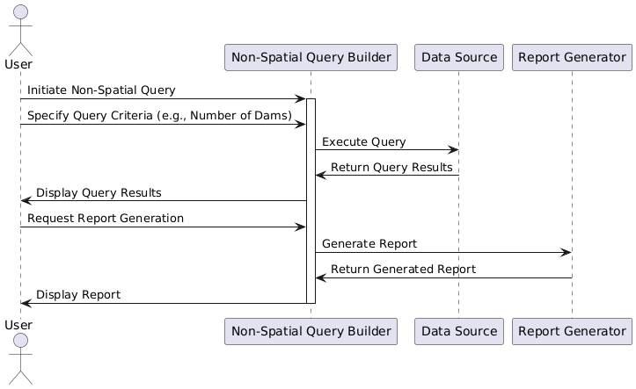

**Code for Figure 006_Visualization_non_spatial_data_SeqDiag_PlantUML**

@startuml

actor User

participant "Non-Spatial Query Builder" as QueryBuilder

participant "Data Source" as DataSource

participant "Report Generator" as ReportGenerator

User -> QueryBuilder: Initiate Non-Spatial Query

activate QueryBuilder

User -> QueryBuilder: Specify Query Criteria (e.g., Number of Dams)

QueryBuilder -> DataSource: Execute Query

DataSource -> QueryBuilder: Return Query Results

QueryBuilder -> User: Display Query Results

User -> QueryBuilder: Request Report Generation

QueryBuilder -> ReportGenerator: Generate Report

ReportGenerator -> QueryBuilder: Return Generated Report

QueryBuilder -> User: Display Report

deactivate QueryBuilder

@enduml

**Frequency of Up-dation:-**As per data made available by state and central water resources departments and agencies.

**Measure of Success:-**Irrigation in India helps improve food security, reduce dependence on monsoons, improve agricultural productivity and create rural job opportunities. Dams used for irrigation projects help produce electricity and transport facilities, as well as provide drinking water supplies to a growing population, control floods and prevent droughts. To achieve better synchronization between the water requirement and supply, time series satellite data will support the irrigation management. It will be a effective & guiding tool for planners and policy makers in developing new water resources projects.

**Input Data Required:-**

**Geospatial Time Series Data:** Hardcopy and softcopy data providing agency is state and central water Required resources departments.

Frequency: As per the data availability

Resolution : NA.

Extent of Coverage: Project based

**Process:**

**Algorithm/Tools:-**

**Step 1:** State and central water resources departments provided the hard copy and softcopy reports/ canal diagrams etc. Hard copy format is first scanned so that further digitization of various datasets and structures associated with a particular water resources projects can be performed.

**Step 2:** Digitization of components of a particular water resources projects such as Dam, Barrage, weir anicuts, power houses etc.

**Step 3:** Preparation of tables containg the various time series well as data related to particular structure/project.

**Step 4:** Topology Correction and data harmonization of digitized data.

**Step 5:** Preparation of map document of water resources data layers along with relevant hydrological layers i.e. Basin, sub basin as well as administrative layers, major rivers, water bodies/ reservoirs with label, legends, scale and suitable visibility of layers at varying scales.

**Step 6:** Hosting GIS layers in the Water Resources Projects Module in QGIS server application.

**Step 7:** Database Server: PostgreSQL is to be used for storing datasets and relationship classes using QSDE.

**Step 8:** Programming platform: ESRI JavaScript AP| is to be used for Map and Custom Widget integration.

**Figure 007_algo_tool_data_SeqDiag_PlantUML**

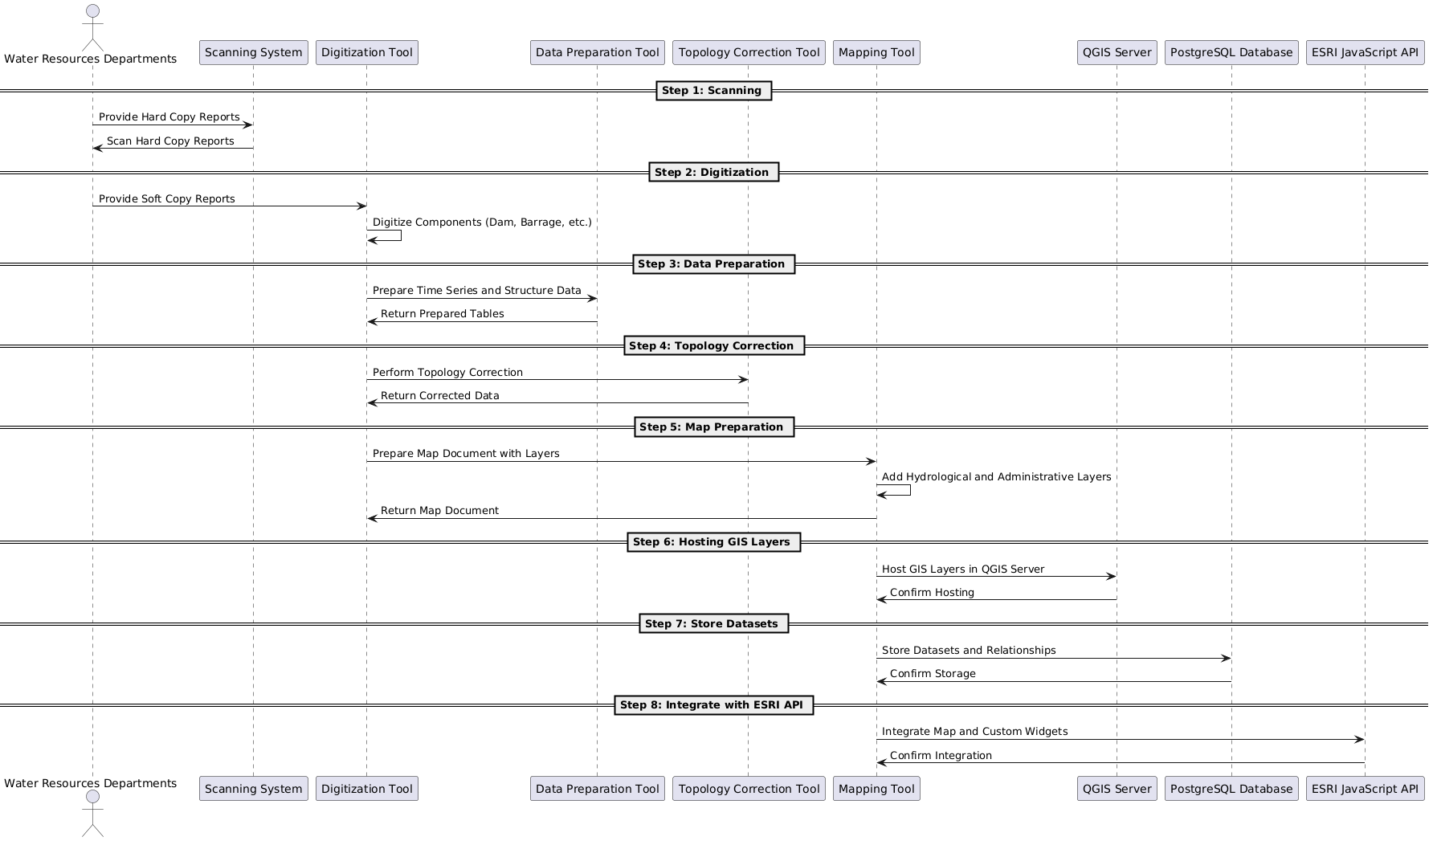

**Code for Figure 007_algo_tool_data_SeqDiag_PlantUML**

@startuml

actor "Water Resources Departments" as WRD

participant "Scanning System" as Scanning

participant "Digitization Tool" as Digitization

participant "Data Preparation Tool" as DataPrep

participant "Topology Correction Tool" as Topology

participant "Mapping Tool" as Mapping

participant "QGIS Server" as QGIS

participant "PostgreSQL Database" as Database

participant "ESRI JavaScript API" as ESRI

== Step 1: Scanning ==

WRD -> Scanning: Provide Hard Copy Reports

Scanning -> WRD: Scan Hard Copy Reports

== Step 2: Digitization ==

WRD -> Digitization: Provide Soft Copy Reports

Digitization -> Digitization: Digitize Components (Dam, Barrage, etc.)

== Step 3: Data Preparation ==

Digitization -> DataPrep: Prepare Time Series and Structure Data

DataPrep -> Digitization: Return Prepared Tables

== Step 4: Topology Correction ==

Digitization -> Topology: Perform Topology Correction

Topology -> Digitization: Return Corrected Data

== Step 5: Map Preparation ==

Digitization -> Mapping: Prepare Map Document with Layers

Mapping -> Mapping: Add Hydrological and Administrative Layers

Mapping -> Digitization: Return Map Document

== Step 6: Hosting GIS Layers ==

Mapping -> QGIS: Host GIS Layers in QGIS Server

QGIS -> Mapping: Confirm Hosting

== Step 7: Store Datasets ==

Mapping -> Database: Store Datasets and Relationships

Database -> Mapping: Confirm Storage

== Step 8: Integrate with ESRI API ==

Mapping -> ESRI: Integrate Map and Custom Widgets

ESRI -> Mapping: Confirm Integration

@enduml

**Data Validation:-**Digitization of components of water resources structures from hard copy/softcopy maps /toposheets format requires geospatial as well as attribute validation time to time.

**Software Technologies:-** QGIS Desktop/ Enterprise

**Dependencies & Risks:**Error during data preparation (hardcopy to GIS data creation) i.e. RMSE error, Interpretational Eros etc. impacts quality of the processed data. Requirement of data updation based upon the current status and data validation by the concerning government agency.

**User Acceptance Testing (UAT):-** NWIC/CWC

**Development Responsibility:** NWIC

**References:-**

https://indiawris.gov.in/wris/#waterResources   
https://cwc.gov.in/

**---End of Document---**